**Title (Times New Roman font, size 14)**

**First Author1, Second Author2, Third Author3 (Times New Roman font, size 12, bold). The name of the presenting author should be underlined.**

1 Affiliation, Address 1, City, Country, contact-author E-mail (Times New Roman font, size 10)

2 Affiliation, Address 1, City, Country (Times New Roman font, size 10)

3 Affiliation, Address 1, City, Country (Times New Roman font, size 10)

**Introduction (Times New Roman font, size 12, bold).** Authors have to use this template to prepare their abstract to be submitted to **BiomMedD 2024** (Times New Roman font, size 12). Citations should be given with numbers in brackets [1] and listed at the end of the abstract.

**Experimental.** The total abstract length should be **1 page** maximum, **no more than 300 words**. Any abstract exceeding 1 page will **not** be considered.

**Results and Discussion.** The text of the abstract should be written using the Times New Roman font, size 12. Subtitles should be in bold.

1 Illustration maximum (Figure or Table).

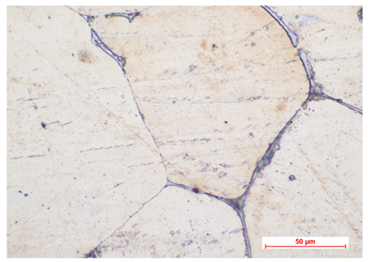

***Fig. 1: Legend (Times New Roman font, size 11, italics)***

**Conclusions.** Save your abstract as a **Word file** before submission. The submission must be done by email at [office@bioremed.ro](mailto:office@bioremed.ro)

**References.** (Times New Roman font, size 11)

[1] Author 1, A.B.; Author 2, C.D. Title of the article. Abbreviated Journal Name Year, Volume, page range

[2] Author 1, A.; Author 2, B. Book Title, 3rd ed.; Publisher: Publisher Location, Country, Year; pp. 154–196.